**Exercise 1: Setting Up JUnit**

**Junit.java :**

package junit;

public class Greeting {

public String sayHello(String name) {

return "Hello, " + name + "!";

}

}

**Test1.java :**

package junit;

import static org.junit.jupiter.api.Assertions.*;

import org.junit.jupiter.api.Test;

class GreetingTest {

@Test

void testSayHello() {

Greeting g = new Greeting();

String result = g.sayHello("Thilak");

assertEquals("Hello, Thilak!", result);

}

}

**Output :**

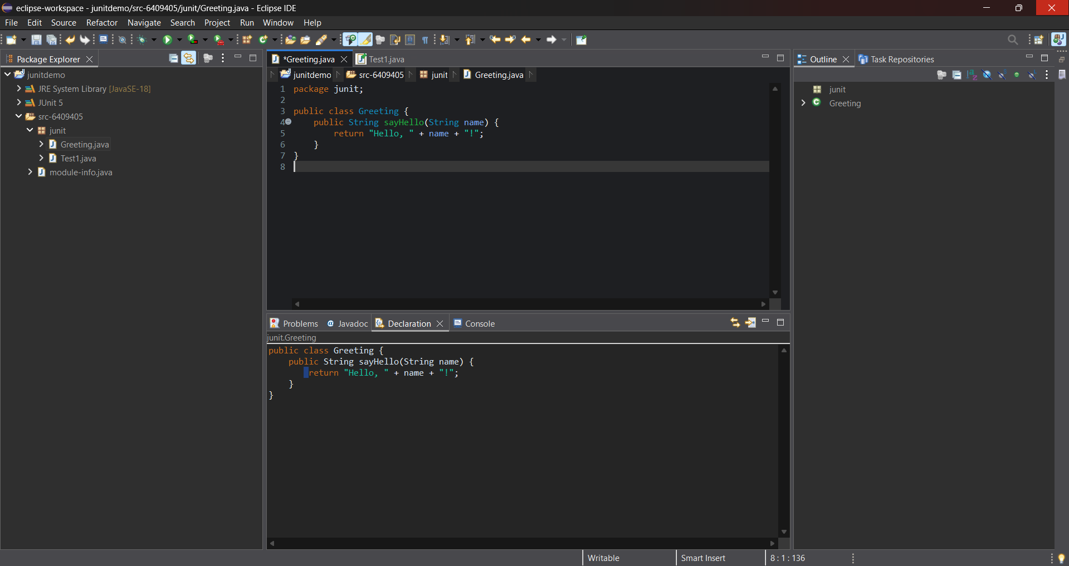

**Exercise 3: Assertions in Junit :**

**Test2.java :**

package junit2;

import static org.junit.jupiter.api.Assertions.*;

import org.junit.jupiter.api.Test;

class test2 {

@Test

void test() {

assertEquals(5, 2 + 3, "2 + 3 should equal 5");

assertTrue(5 > 3, "5 should be greater than 3");

assertFalse(5 < 3, "5 should not be less than 3");

String str = null;

assertNull(str, "String should be null");

Object obj = new Object();

assertNotNull(obj, "Object should not be null");

}

}

**Output:**

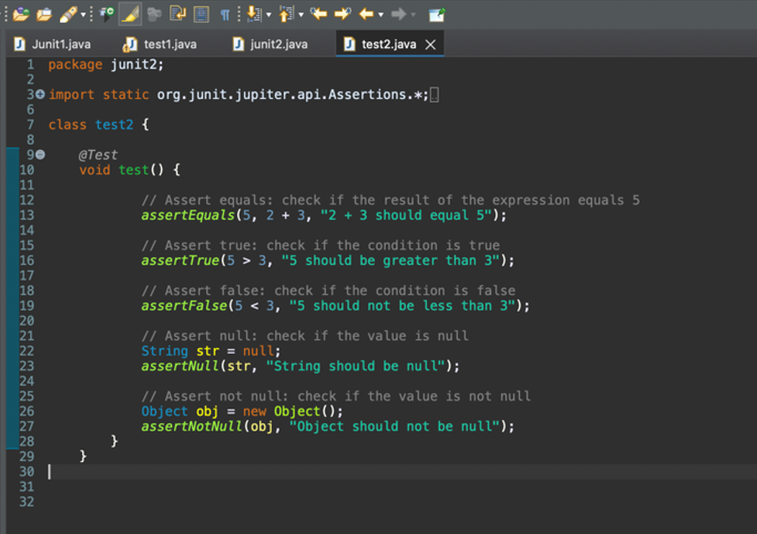

**Exercise 4: Arrange-Act-Assert (AAA) Pattern, Test Fixtures, Setup and**

**Teardown Methods in Junit**

**TemperatureConverter.java**

package Junit4;public class TemperatureConverter { public double celsiusToFahrenheit(double celsius) { return (celsius * 9 / 5) + 32; } public double fahrenheitToCelsius(double fahrenheit) { return (fahrenheit - 32) * 5 / 9; }}

**TemperatureConverterTest.java**

package Junit4;

import org.junit.jupiter.api.*;

import static org.junit.jupiter.api.Assertions.*;

class TemperatureConverterTest {

private TemperatureConverter converter;

@BeforeEach

void setUp() {

System.out.println("Setting up...");

converter = new TemperatureConverter();

}

@AfterEach

void tearDown() {

System.out.println("Tearing down...");

converter = null;

}

@Test

void testCelsiusToFahrenheit() {

// Arrange

double celsius = 0;

// Act

double result = converter.celsiusToFahrenheit(celsius);

// Assert

assertEquals(32.0, result, 0.001, "0°C should be 32°F");

}

@Test

void testFahrenheitToCelsius() {

// Arrange

double fahrenheit = 212;

// Act

double result = converter.fahrenheitToCelsius(fahrenheit);

// Assert

assertEquals(100.0, result, 0.001, "212°F should be 100°C");

}

}

**Output :**

